Comparative Analysis of Machine Learning Models for State of Charge Prediction in V2G Systems: Insights from a MATLAB Simulated Microgrid Environment
Mahmoud Mohammadnezhad Kiasari
Department of Electrical and Computer Engineering
Dalhousie University
Halifax, Canada
Mahmoud.Kiasari@dal.ca
Hamed H. Aly
Department of Electrical and Computer Engineering
Dalhousie University
Halifax, Canada
Hamed.Aly@dal.ca

Abstract— The burgeoning integration of renewable energy and Vehicle-to-Grid (V2G) systems into microgrids underscores the imperative for sophisticated predictive models to forecast the State of Charge (SoC) of electric vehicles (EVs), a pivotal aspect of V2G efficiency. Leveraging a model derived from MATLAB examples, this study embarks on a passive mode analysis to compare the efficacy of three distinguished machine learning algorithms—Extreme Gradient Boosting (XGBoost), Recurrent Neural Networks (RNNs), and Support Vector Regression (SVR)—in predicting the SoC for EVs within a simulated microgrid framework. The simulation meticulously replicates a microgrid composed of a diesel generator, renewable energy sources (photovoltaic and wind), a V2G system, and varying consumer load profiles, mirroring the energy dynamics of a community comprising a thousand households. Emphasis is placed on five V2G user profiles to emulate diverse real-world scenarios. The evaluation of the model's predictive performance is meticulously conducted through Mean Squared Error (MSE), R-squared values, and k-fold cross-validation metrics, facilitating a comprehensive understanding of their predictive accuracy and robustness. This investigation enriches the microgrid management discourse, highlighting the potential of passive mode analysis in MATLAB to enhance the operational efficacy of microgrid systems. By elucidating the comparative strengths and limitations of each predictive model, the study paves the way for future research endeavors aimed at refining predictive methodologies in the energy sector.
Keywords—Renewable Energy, Wind, Solar, Machine Learning, MATLAB

Introduction
The advent of the smart grid and the increasing integration of renewable energy sources have significantly altered the landscape of energy systems, leading to more sustainability and grid reliance. The concept of microgrids is central to this transformation, where they can operate autonomously or in conjunction with the main power grid. Having the help of other sources could elevate the efficiency of the system while aiding in more flexibility and reliability of the system. As one of the pivotal innovations, V2G technology emerges within the microgrid, enabling the EVs not only to be charged but also to feed electricity back into the grid, thereby acting as mobile energy storage.

The effective integration of this technology depends on the accurate prediction of the SoC of EVs, a critical parameter that secures the optimal operation of both EVs and grids in each stage of charging and discharging. This forecasting facilitates EV usage as a load or source, of grid stability, especially with the unpredictable nature of renewable energies like wind and solar. The main focus of this work is also dedicated to this matter, where the development of robust prediction is paramount, with machine learning offering guaranteeing revenue due to its applicability in handling complex and non-linear correlations inherent in energy sources.

This study delves into a comparative analysis of three advanced machine learning methods, XGBoost, RNN, and SVR in predicting EV SoCs within a microgrid environment. MATLAB-Simulink, notorious for its excellence in simulations, particularly for its remarkable V2G simulation capabilities, is to be applied in the study. This model simulates a microgrid composed of a diesel generator, renewable energy sources (PV and wind farms), a V2G system, and 5 different consumer load profiles for 10 different days. The model itself only implements some random inputs for each part, as in this work, different realistic sources would be used to resemble the real-time situation for simulation and the machine learning methods to be as much as close to the reality. The total aim is to elucidate the predictive accuracy, reliability, and computational efficiency of each model in the context of V2G, to contribute valuable insights to microgrid management optimization and advancing sustainable energy systems.

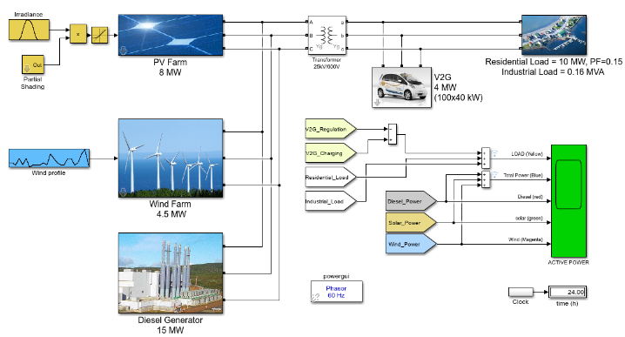
Figure 1 24-hour Simulation of V2G System in Simulink

This paper builds on previous foundations and studies on the associated topic. In this study[1], authors have explored the capabilities of machine learning models, especially deep learning techniques, in the short-term forecasting of EV load. Also, another work[2] has used XGBoost and Random Forest as its method of EV energy consumption. While most of these works have been working on different machine learning techniques in various scenarios, a distinct gap is evident in the comprehensive comparison analysis of mentioned methodologies, to verify their effectiveness in SoC forecasting. Moreover, the integration of these methods with the Simulink-based simulation model implements real world data to mirror authentic V2G scenarios. This oversight presents a significant research opportunity, not only to have a thorough comparison among three techniques, to capture their competence in dealing with realistic scenarios, but also hut also harness the power of Simulink’s robust simulation capabilities. ( Use other different sources and also use some gaps between the work and previous ones ).

The paper is organized as follows. Section 2, has a brief explanation related to each method. Section 3, is about the data and prediction models architecture. In section 4, there is a proper definition of model implementation alongside the validations. And lastly, for the final sections, results and future works are mentioned.

XGBoost, RNN, and SVR
The advanced machine learning methods have garnered significant attention in this paper due to their capabilities and successes across various domains, including renewable energy predictions, have been chosen. In this section, an overview of each method by highlighting their theoretical foundations, key features, and applicability[3] to this matter, are discussed.

- XGBoost: This method stands as a powerful ensemble learning method, empowered by the gradient boosting framework. Its renowned because of its efficiency, accuracy, and scalability in handling large and complex datasets. Decision Trees are the backbone of XGBoost, while it operates by constructing a sequence of them, where each successive trees corrects errors made by the previous ones, leads to the model improvement. Missing data management, captivating non-linearity correlation among datasets, and the feature importance scores make XGBoost a valuable method where understanding the influence of various predictors is crucial[2].
- SVR: This method, extends the principles of Support Vector Machines (SVM) to regression problems, emphasizing on detecting a function that could deviated from the actual observed values by value that does not exceed a specific threshold that declared for itself. Main characteristics of this model, is the kernel function, leads the model to have its operation in a high-dimensional space, to capture the non-linearity. SVR, values for its robustness, in high dimensional datasets scenarios mostly and handling the data complexity[4]
- RNN: Represents a class of neural networks designed to the patterns in sequences of data recognition. This process makes the data ideal for time series forecasting problems, like wind prediction. Unlike previous feedforward neural networks, RNNs use internal loops that allow information to persist, enable them to maintain the memory of previous inputs. This matter aids the model to exhibit temporal dynamic behavior. RNNs achieve this feature by incorporating feedback connections that feed the output of a layer at one time step as input to the same layer at the next time step, thus considering the temporal correlation within the sequence. Having said about this valuable characteristic, RNN is highly effective for modeling sequential data and predicting future elements of the sequence[5].

Leveraging the strengths of each method within a comparative situation, by the help of Simulink model alongside the rea;-world data and the power of Python programming language, aimed to identifying the most effective machine learning model for predicting the SoC of EV cars in one-hour ahead scenario. The sophisticated ensemble learning capabilities of XGBoost, the sequential data processing of prowess of RNN, and the adept non-linearity management of SVR, are going to be compare with each other, which represent a multifaceted approach to tackle the inheritance complexities of SoC forecasting in different scenarios. Acknowledging the implementation of real-world data related to renewable energies and other power output by considering trustworthy datasets like NREL and MERRA-2 could be emphasized as one of the pros of this paper. The reason of this usage is to fill the gap between theorical accuracy and practical capabilities, especially in the deployment phase of trained model.

data and prediction models architecture
Forecasting has faced an enormous advance with the advent of machine learning (ML). This transformation mainly relies on the vast amount of data that could be gathered by industries that are collected in datasets or websites like Renewable. ninja, which researchers and engineers have access to[10]. Among all ML techniques, this work focused on three specific ones. ANN, SVR ( the regression model of SVM ), and LSTM were chosen for their ability to handle the non-linear and intricate patterns characteristic of wind data[11].
- ANN: Inspired by the neural networks in the animal brains, are adept at recognizing patterns and dependencies within the data which makes it ideal for forecasting tasks that are involved with complex and dynamic datasets. Because of their layered structures, modelling the data at various abstraction levels, empowering their predictive capabilities, mainly for the time-series data like the one that this work focused on, is achievable[7].
- SVR: Stands out for its ability to manage high dimensional data and complex model non-linearity through the kernel trick and optimizing the balance between model intricacy and predictive accuracy, which is crucial in a noisy environment[12].
- LSTM: These are specialized forms of Recurrent Neural Networks (RNNs), particularly effective in capturing long-term dependencies in the time series data, which is a common aspect of wind energy, due to their unique memory cell structure[13].

Having these three models as a hybrid ML framework offers a promising approach for optimal RE forecasting. The synergy between ANN, SVR, and LSTM in the hybrid setup aims to implement the strengths of each model. The pattern recognition of ANN, the non-linearity handling of data in SVM, and the temporal data processing power of LSTM. This collaboration not only aims to elevate the accuracy of wind power generation but also could be a robust response to other challenges posed by the variability and complexity of REs.

Having dysconnectivity between trained models and deployed ones because of a lack of real-world data is evident in some previous works. Obtaining a precise model with high accuracy is not always the actual outcome, but most importantly, the data that these models are trained on should be realistic. By incorporating the MERRA-2 dataset, this gap would be significantly bridged. Its comprehensive and exact data from the atmosphere provides a robust foundation for a more realistic forecasting model.

Integrated Data analysis and forecasting models

Data Collection and Preparation
The methodology for achieving this goal would start with a precise data collection of different environmental features from other locations of provinces in Canada. The reason for choosing these places is to put the training model with various inputs to be trained better. As explained before, a trustful organization like NASA gave us access to its database that uses MERRA-2. This atmospheric reanalysis dataset further enriches the analysis with important weather-related factors. However, this enormous dataset, from 2000 to 2019 with three different locations, is raw and needs to be done through data cleaning and preprocessing first. After doing all of these steps, it would be ready for the model implementation. For this part, ANN, SVR, and LTSM will be used. Each model brings its capabilities, and its selection is made because of its efficiency in capturing complicated interconnections within the dynamic data. In the end, using the evaluation metrics like Mean Squared Error (MSE), the model's efficiency would be assessed.
Moreover, three different wind turbines were focused upon, each has been chosen because of its exceptional wind generation capacity, designs, and technological advancements. The Enercon E126/6500 was the first one, that had a rotor diameter of 126 meters and a hub height of 136 meters, with a rated power capacity of 6Mw up to 7.5Mw. Because of its gearless design and direct drive mechanism, this turbine is used in places that have a high potential for wind power generation. This specific reason was the main one for having the turbine as one of the candidates for this work. The Siemens SWT-3.6-120 was the second option for this work. This turbine features a rotor diameter of 120 meters and a typical hub height of 90 meters, which have a capacity of 3.6Mw for wind generation. Because of its reliability, this turbine has been used widely across diverse wind regions, especially in the Canadian context, where wind speed and direction can change from one place to another. As a mid-capacity turbine, the adaptability to varying wind conditions and its robust design were convincing enough to be one of the options. Lastly, for the low-range wind generation, V90-2.0 has been chosen as it has a rotor diameter of 90 meters and a standard hub of 80 meters, providing a rated capacity of 2Mw. This turbine can be ideal for areas with average wind speeds. The selection of these three, not only spanned a wide range of turbine technologies and capacities but also enabled a detailed investigation into the adaptability and performance of these turbines under the diverse wind conditions encountered in Canada[14].
Since 1980, the MERRA-2, developed by NASA’s Global Modeling and Assimilation Office, has faced fundamental enhancements, making it the backbone of many atmospheric data analysis studies. Also, NASA’s ozone profile has been used in this dataset since 2004, which enriched its superiority. The Fidelity of the dataset is sustained by improvements in both Gridpoint Statistical Interpolation (GSI) and Goddard Earth Observing System (GEOS), maintaining its resolution at 50km in the latitudinal direction[15]. The integration of this data set into this study, due to its refined spatial and temporal resolution, which contains various environmental features like air temperature or wind speed, is inevitable. Incorporating vast satellite observations with advanced data adjustments aids this dataset in gathering accurate and consistent valuable information from the atmosphere. This evolutionary enhancement in data quality enriches the understanding of climate dynamics, underpinning the robustness of this study's forecasting by providing thorough information on the features of atmospheric conditions that have an enormous impact on renewable energy generation.

Data Cleaning and Integration
This section will explore the meticulous processes of ensuring the dataset quality, consistency, and comparability. Using powerful programming languages like Python aims to refine the raw data gathered into a coherent, analysis-ready format. Some issues like missing values, outliers, and inconsistencies across the dataset were issued, ensuring a solid foundation for accurate forecasting. The data source variety leads to the fact that the ML system would face different units of measurement, normalization, and transformation to establish a robust essential for quality assurance. In the following parts, each step taken to prepare the dataset for the ML model training has been clarified.
- Missing Data Handling: One specific flaw in each dataset is the missing values of each feature. This issue could lead to some inaccuracy and malfunction in the trained model. Based on this matter, missed values are interpolated using the known dataset to ensure continuous and uninterrupted information. For instance, hourly wind power generation could be filled with the means of other values. Furthermore, the usage of statistical methods like standard deviation, some outlier data that could be stored because of human error, or the measurement devices' complications could be identified to prohibit any misjudgments for the trained model. Maintaining thresholds have been chosen for this study.
- Data Normalizations and Transformations: Normalization of data processes into a standard range ensures uniformity in data units and facilitates the comparison of various scale features. A z-score is a common way, where each data points to the standard deviation of that specific feature value.
- Integration Techniques: Combining datasets from different sources was another part of this work. As MERRA-2 provides vast information, gathering, categorizing, and combining those materials was another challenge. Using Application Program Interface (APIs) that Renewable provided. The Ninja website was a great aid in overcoming this obstacle alongside the help of the Pandas library in Python[16]. However, some parts of this process must be done manually by putting different environmental datasets alongside the 10 years of other locations. This integration aims to ensure that the ML model is supplied with the proper dataset for analyzing the correlation among the features.
- Efficiency Consideration: Having a large number of datasets alongside its complexity, would have some issues like computation time. Using parallel processing would address these issues as it can enhance computational efficiency, leading to faster data analysis, model training, and other tasks. This strategy elevates modern hardware's capabilities and optimizes the utilization of computing resources.

Model Configuration
In this section, intricate elaboration will be on the selected ML models for the study. For this work, ANN, SVR, and LSTMs have been chosen. The complexity of the data set, with the varied variables and temporal dynamics, needed a profound model can find the patterns among the features. For the ANN and LTSM models, careful consideration was to their hyperparameters, hidden layers or neurons within each layer, to capture the correlation among the input datasets, thereby enhancing predictive performance. The number of hidden layers in the ANN model was designed in a way to commence with a size roughly half of the input features, to employ a geometric progression for decreasing the numbers of subsequent layers. Using this way aids in gradually concentrating the most useful information for the task.
An activation function in ML, mostly used in Networks, is a mathematical function that would be applied to each node’s inputs to produce an output signal for the next layer, which is the new input for that specific layer. The main task of having these techniques in the training process is to bring non-linearity to the system, which could help the model capture the complexity among the inputs. Without having an activation function, NN would only focus on linearity, by considering all its depth, which restricts its ability to find the true pattern, such as those found in image recognition or natural language processing. Rectified Linear Units (ReLU), sigmoid, and Softmax are the common ones, each with their specific characteristics[17].

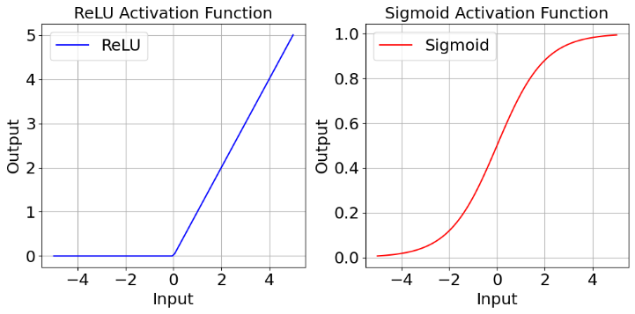
Figure 2 ReLU and Sigmoid functions

 | $$f\left(x\right)=max⁡(0,x)$$ |  |  | (1)
 |  | $$f\left(x\right)= \frac{1}{1+ e^{-x}}$$ | (2)

Evaluation Metrics
Since wind power forecasting contains continuous numbers, the work is on regression, and because of that, the evaluation metrics would be chosen. Two important metrics have been used in this work. The reason for having different metrics is that only concluding the best method based solely on one of them is not accurate, and the task should be trustworthy enough by considering different aspects of the evaluation for future works.
- Mean Squared Logarithmic Error: This metric determines the ratio between the actual and predicted values after applying the natural logarithm to each. Unlike the Mean Squared Error (MSE), it is useful for the time that the goal is to penalize underestimations more than overestimations and also deal with numbers near zero, since as part of scaling inputs and outputs, numbers would be transformed. The range of this metric is between 0 and 1, with 0 indicating the perfect predictions.

 | $$MSLE= \frac{1}{n} \sum_{i=1}^{n}{{(\log\left(1+y_{i}\right)-\log\left(1+ {\overline{y}}_{i}\right))}^{2}}$$ | (3)
- R – R-squared (Coefficient of Determination): R² is another statistical metric that provides the quality of fit of a regression model. It quantifies the proportion of variance in the output variable which can be explained by using input features. This metric represents the power of the model in the attribute of capturing the variance in the target variable. The range is like the MSE, from 0 to 1 and the formula is at Equation (2). SSR is the sum of squared residuals, and SST is the total sum of squares.

 | $$R^{2}=1- \frac{SSR}{SST}= 1- \frac{\sum_{i=1}^{n}{{(y_{i}- {ŷ}_{i})}^{2}}}{\sum_{i=1}^{n}{{(y_{i}- \overline{y})}^{2}}}$$ | (4)
- K-fold cross-validation: This is a statistical method used to evaluate the skill of ML models. It involves partitioning the original dataset into ‘K’ equal subsets, using one subset for validation while the remaining ‘K-1’ subsets are used for training, and repeating the process for ‘K’ times with each subset serving as the validation once. In the end, the means of overall performance would be considered as the final evaluation[18].

 | $$P= \frac{1}{K}\sum_{i=1}^{K}{P_{i}}$$ | (5)

model implementation and validation

Data Preparation and Preprocessing
The foundation of this model implementation began with the data collection phase, where MERRA-2 was used by considering three different locations in Canada (Manitoba, Nova Scotia, and British Colombia) spinning the years 2017 to 2019. One hour time interval from the MERRA-2 as inputs for network training, 10 × 236314 numbers of dataset with their within features, and wind generation taken as the target data. They have divided into 70% for training, 15% for validation and the rest for testing. The data characterized included metrics from three different turbines: Enercon E126 6500, Siemens SWT 3.6, and V90 2000. The specifics of steps and input/output data can be seen in Fig 2 and Fig 3.

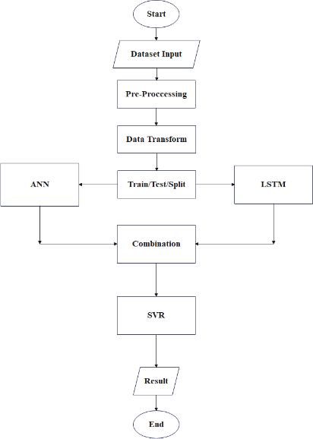
Figure 3 Model training steps

As the ML models should work with the consistent data type, one-hot encoding transform has been used to convert the string files, like the location name, to the format that could be effectively used by models. Moreover, StandardScaler has been applied to standardise the data to have a mean of zero and a standard deviation of one ( Z-score ). This step was crucial, as it involved dealing with inputs and outputs in various formats, which could lead to the observation of differing numerical values.

Model Architecture and Hybrid Model Formulation
The work offered the integration of two sophisticated neural networks: the ANN and LSTM. The ANN component was designed with an input layer of 256 neurons, followed by two hidden layers each comprising 128 neurons, all in ReLU activation function, and culminating in a linear activation function as an output layer. The aim was this structure was to capture the complex relationship among the features. Parallelly, the LSTM model has 128 neurons as its first layer, followed by 64 neurons at another one, all in ReLU, and lastly finished by one linear activation function hidden layer. The usage of this model helped the model to modify the deep temporal dependencies among features. A novel aspect of this work was the integration of the last two mentioned models, serving as a composite input for the SVR. This hybrid model leverages the strengths of both neural networks and SVR, for a synergic effect and elevated prediction accuracy.
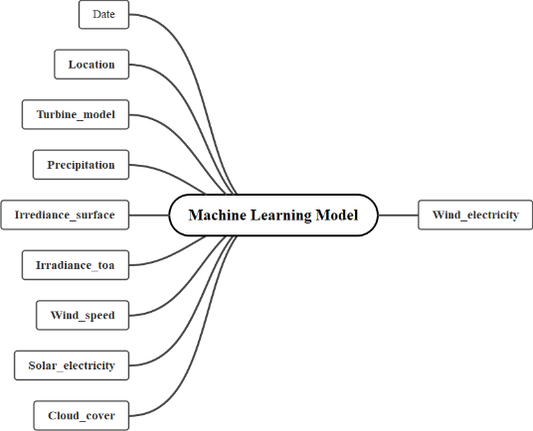
Figure 4 ML inputs and outputs

Model Training and Validation
In this comprehensive ML approach, raw data first undergoes standardization using StandardScaler and it would be reshaped into three-dimensional arrays to meet the LSTM model requirements, alongside the ANN, both would be trained on this preprocessed data, reserving 20% as a validation set to guard against overfitting. Post-training, predictions from both previous models are concatenated, forming a proper input for the SVR, which acts as a meta-model. In the end, using this sophisticated, multi-staged training process will be evaluated in the next part to assess its value.

Performance Evaluation
For the evaluation process, R² and MSLE as the principal metrics in a K-fold cross-validation framework to assess the effectiveness of the model. R², the coefficient of determination, provided insights into the model by quantifying the variance in the dependent variable predictable from the independent variables, while MSLE, is sensitive to relative errors. Implementing K-fold cross-validation, where the dataset was divided into 'K' subsets, allowing for a comprehensive evaluation across diverse data segments, enhancing model validation by mitigating overfitting risks and ensuring robust performance estimates reflective of the model's behaviour on unseen data. Using this robust assessment could help to ensure the stability and reliability of this model across the different scenarios by having a vast amount of data.
In the regression field, sensitivity tests play a crucial role in understanding the robustness of forecasting outcomes. By, systematically alternating the tolerance for input features, and the usage of other evaluation metrics, the effectiveness of these alters can be assessed[19]. In this work, this test was done at the last stage, where the combination data would be injected into the SVR model, by considering three different numbers for the ‘epsilon’ parameter in this SVR training model. This part manages the epsilon tube within which no penalty is associated with the training loss function within a distance epsilon. Different values of this could help to control the width of the epsilon-insensitive tube, which modifies the number of support vectors and the degree of smoothness in the regression model results.

Results
The results obtained from this model are presented in this section. Through a complete assessment, different aspects of this model have been observed. A comparative analysis was presented in Table 1 to illustrate the performance metrics, R² and MLSE values, both integral for performance assessment. As it can be seen, the usage of K-fold, while proving how robust the model is, demonstrated an improvement in the model execution. However, this progress is not sensible, yet it can be a proper reason for to effectiveness of the hybrid model.
For the performance, the MSLE served as a vital metric, depicting the discrepancies in predicted value versus the actual one during both training and validation. These processes have been done through 50 epochs, that have been plotted in Figure 4, revealing the constant reduction in error, thus understanding the model’s ability to generalize and learn the data effectively.
For the sensitivity check of inputs, an analysis has been performed to measure the model’s responsiveness to variations in inputs. The visualization of three different sensitivities, 0.1, 0.2 and 0.3, has been demonstrated in Figure 5, which shows the robustness and relative influence on the predictive outcome. The necessity of this experiment was to identify how varying the sensitivity, which here is the SVR, could impact the prediction. Maintaining high R² and small MLSE, yet slightly increasing during the sensitivity test, impacts the successful capturing of underlying data dynamics and model adoption at managing proportional divergences.

Table 1 Evaluation metrics for the model

Evaluation Metrics
Evaluation Metrics | R² | MSLE
Hybrid | 0.9896 | 0.1724
Hybrid-K fold | 0.9903 | 0.1690

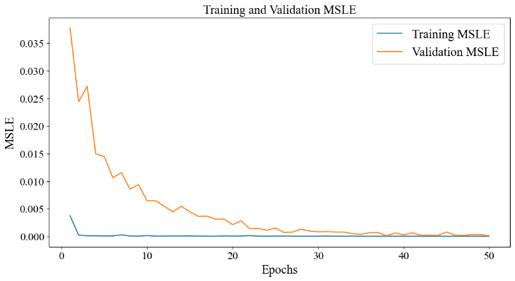
Figure 5 Training and validation MSLE

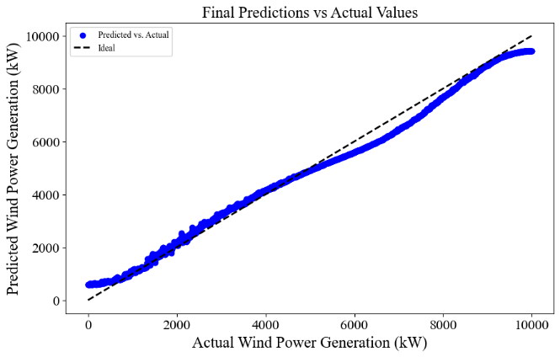
Figure 6 Final prediction vs actual values

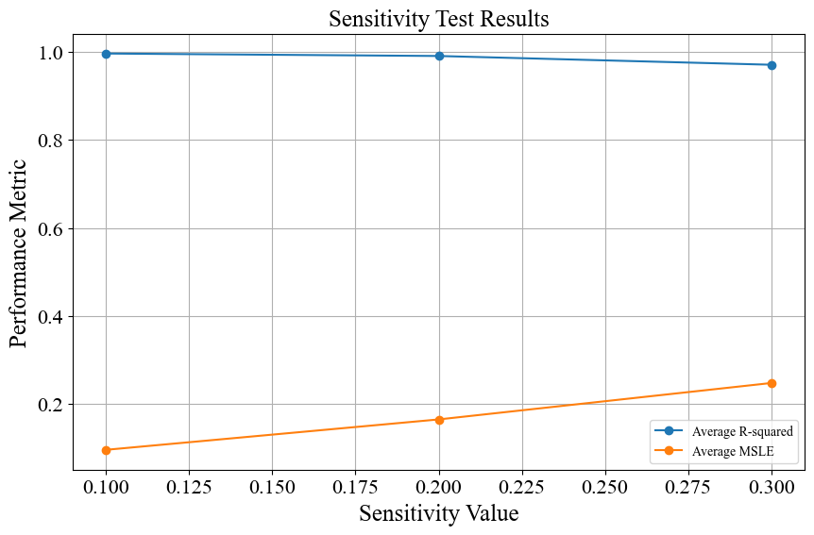
Figure 7 Sensitivity test results.

Conclusion and future works
The research undertaken presents a compelling narrative on enhancing wind power generation forecasting through an innovative hybrid ML framework, by integrating solar and other environmental factors and the comprehensive MERRA-2 dataset.
The architecture of the proposed model, combining the strength of ANN, LSTM, and SVR, leads to more reliable and precise forecasting. The results underscore the model’s robustness throughout this process. R2 and MSLE have been used in this work, alongside the implementation of K-fold cross-validation. The sensitivity analysis, revealed the model's adaptability to varying input parameters, particularly within SVR, by considering different ‘epsilons’. Using this method, evaluate the model flexibility and responsiveness against the input variations.
Looking ahead, the foundation of this work could pave the way for several directions in RE forecasting. Future works could explore the integration of additional predictive features to elevate the model's accuracy. The exploration of alternative ML models, or various hybrid ones, could offer new perspectives on forecasting challenges. Moreover, the scalability of this study model invites investigation through different geographical locations and integration of other turbines, broadening the scope of RE management.

References
[1] G. Vishnu, D. Kaliyaperumal, P. B. Pati, A. Karthick, N. Subbanna, and A. Ghosh, “Short-Term Forecasting of Electric Vehicle Load Using Time Series, Machine Learning, and Deep Learning Techniques,” WEVJ, vol. 14, no. 9, p. 266, Sep. 2023, doi: 10.3390/wevj14090266.
[2] H. Rathore, H. K. Meena, and P. Jain, “Prediction of EV Energy consumption Using Random Forest And XGBoost,” in 2023 International Conference on Power Electronics and Energy (ICPEE), Bhubaneswar, India: IEEE, Jan. 2023, pp. 1–6. doi: 10.1109/ICPEE54198.2023.10060798.
[3] N. E. Benti, M. D. Chaka, and A. G. Semie, “Forecasting Renewable Energy Generation with Machine Learning and Deep Learning: Current Advances and Future Prospects,” Sustainability, vol. 15, no. 9, p. 7087, Apr. 2023, doi: 10.3390/su15097087.
[4] S. Jumah, A. Elezab, O. Zayed, R. Ahmed, M. Narimani, and A. Emadi, “State of Charge Estimation for EV Batteries Using Support Vector Regression,” in 2022 IEEE Transportation Electrification Conference & Expo (ITEC), Anaheim, CA, USA: IEEE, Jun. 2022, pp. 964–969. doi: 10.1109/ITEC53557.2022.9813811.
[5] H.-A. I. El-Azab, R. A. Swief, N. H. El-Amary, and H. K. Temraz, “Seasonal electric vehicle forecasting model based on machine learning and deep learning techniques,” Energy and AI, vol. 14, p. 100285, Oct. 2023, doi: 10.1016/j.egyai.2023.100285.
[6] M. A. P. Mahmud and S. H. Farjana, “Comparative life cycle environmental impact assessment of renewable electricity generation systems: A practical approach towards Europe, North America and Oceania,” Renewable Energy, vol. 193, pp. 1106–1120, Jun. 2022, doi: 10.1016/j.renene.2022.05.031.
[7] K. L. Jorgensen and H. R. Shaker, “Wind Power Forecasting Using Machine Learning: State of the Art, Trends and Challenges,” in 2020 IEEE 8th International Conference on Smart Energy Grid Engineering (SEGE), Oshawa, ON, Canada: IEEE, Aug. 2020, pp. 44–50. doi: 10.1109/SEGE49949.2020.9181870.
[8] I. Rahimi, M. R. Nikoo, and A. H. Gandomi, “Techno-economic analysis for using hybrid wind and solar energies in Australia,” Energy Strategy Reviews, vol. 47, p. 101092, May 2023, doi: 10.1016/j.esr.2023.101092.
[9] F. Fattori, N. Anglani, I. Staffell, and S. Pfenninger, “High solar photovoltaic penetration in the absence of substantial wind capacity: Storage requirements and effects on capacity adequacy,” Energy, vol. 137, pp. 193–208, Oct. 2017, doi: 10.1016/j.energy.2017.07.007.
[10] “Renewable.ninja.” Jan. 27, 2024. Accessed: Jan. 27, 2024. [Online]. Available: https://www.renewables.ninja
[11] S. M. Valdivia-Bautista, J. A. Domínguez-Navarro, M. Pérez-Cisneros, C. J. Vega-Gómez, and B. Castillo-Téllez, “Artificial Intelligence in Wind Speed Forecasting: A Review,” Energies, vol. 16, no. 5, p. 2457, Mar. 2023, doi: 10.3390/en16052457.
[12] L.-L. Li, X. Zhao, M.-L. Tseng, and R. R. Tan, “Short-term wind power forecasting based on support vector machine with improved dragonfly algorithm,” Journal of Cleaner Production, vol. 242, p. 118447, Jan. 2020, doi: 10.1016/j.jclepro.2019.118447.
[13] F. Shahid, A. Zameer, and M. Muneeb, “A novel genetic LSTM model for wind power forecast,” Energy, vol. 223, p. 120069, May 2021, doi: 10.1016/j.energy.2021.120069.
[14] A. Bensalah, M. A. Benhamida, G. Barakat, and Y. Amara, “Large wind turbine generators: State-of-the-art review,” in 2018 XIII International Conference on Electrical Machines (ICEM), Alexandroupoli: IEEE, Sep. 2018, pp. 2205–2211. doi: 10.1109/ICELMACH.2018.8507165.
[15] Nasa, “Modern-Era Retrospective analysis for Research and Applications, Version 2.” Accessed: Feb. 04, 2024. [Online]. Available: https://gmao.gsfc.nasa.gov/reanalysis/MERRA-2/
[16] ActiveState, “What Is Pandas In Python? Everything You Need To Know.” Accessed: Aug. 09, 2022. [Online]. Available: https://www.activestate.com/resources/quick-reads/what-is-pandas-in-python-everything-you-need-to-know/
[17] S. R. Dubey, S. K. Singh, and B. B. Chaudhuri, “Activation functions in deep learning: A comprehensive survey and benchmark,” Neurocomputing, vol. 503, pp. 92–108, Sep. 2022, doi: 10.1016/j.neucom.2022.06.111.
[18] Y. Jung and J. Hu, “A K -fold averaging cross-validation procedure,” Journal of Nonparametric Statistics, vol. 27, no. 2, pp. 167–179, Apr. 2015, doi: 10.1080/10485252.2015.1010532.
[19] R. A. Ashley and C. F. Parmeter, “Sensitivity Analysis of an OLS Multiple Regression Inference with Respect to Possible Linear Endogeneity in the Explanatory Variables, for Both Modest and for Extremely Large Samples,” Econometrics, vol. 8, no. 1, p. 11, Mar. 2020, doi: 10.3390/econometrics8010011.

